What is Spot instance?
The Shared product Object Tree (SPOT) is a fundamental resource in the NIM environment. It is required to install or initialize all types of machine configurations.
A SPOT provides a /usr file system for diskless and dataless clients, as well as the network boot support for all clients.Everything that a machine requires in a /usr file system, such as the AIX® kernel, executable commands, libraries, and applications are included in the SPOT.
Machine-unique information or user data is usually stored in the other file systems. A SPOT can be located on any standalone machine within the NIM environment, including the master. The SPOT is created, controlled, and maintained from the master, even though the SPOT can be located on another system.
What are the sources of creating spot instance?
- ISO images (Use the same server type of affected server ISO or download it from IBM Entitled System Support)
- MKSYSB backup (Use the same server type of affected server)
Use ISO image as lpp_source to create a spot instance:
- Download the similar version of base ISO image from IBM Entitled System Support
- Save the image in NIM server.
- Command to create lpp_source:
# nim -o define -t lpp_source -a server=master -a location=<location of storing lpp_source> -a source=<location of ISO image> -a packages=all <lpp_sourcename>
- Create a lpp_source from the image.
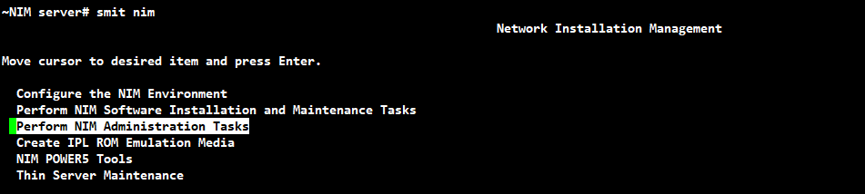
Select “Perform NIM Administration Tasks” and Enter.
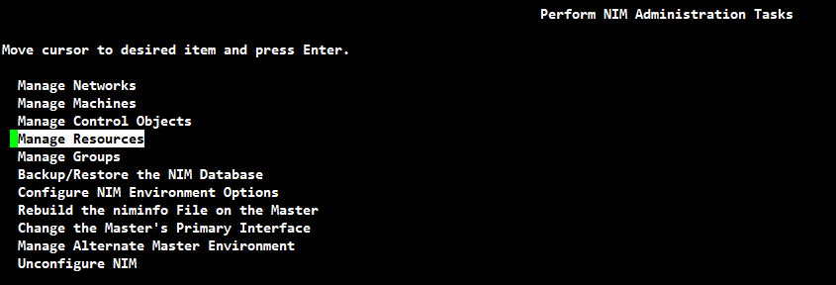
Select “Manage Resources” and Enter.
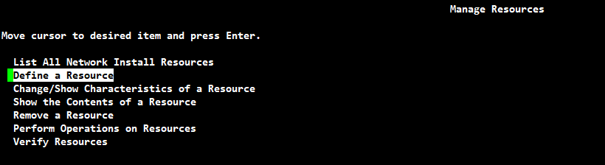
Select “Define a Resource” and Enter.
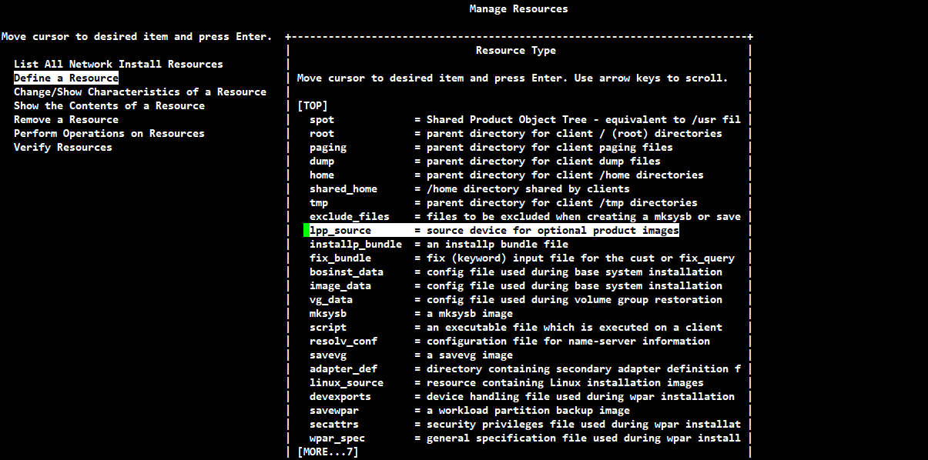
Select “lpp_source = source device for optional product images” and Enter.

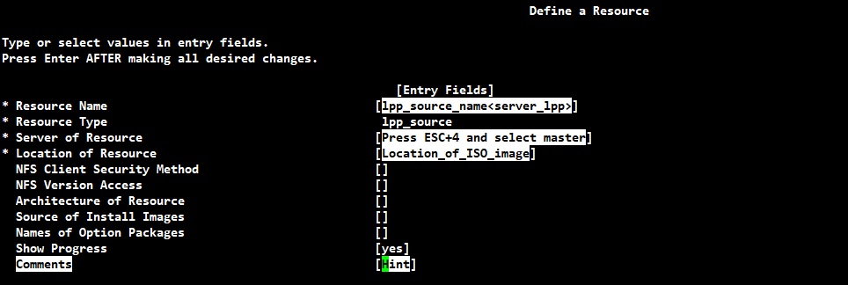
Fill the form with appropriate details and hit enter.
- Verify the created lpp resource
  - lsnim -c resources
  - lsnim -l <created resource name>
- Create spot instance by using created lpp_source.
# nim -o define -t spot -a server=master -a location=<location of spot files> -a source=<lppsource_name> <spot_name>
Select “Perform NIM Administration Tasks” and Enter
Select “Manage Resources” and Enter.
Select “Define a Resource” and Enter.
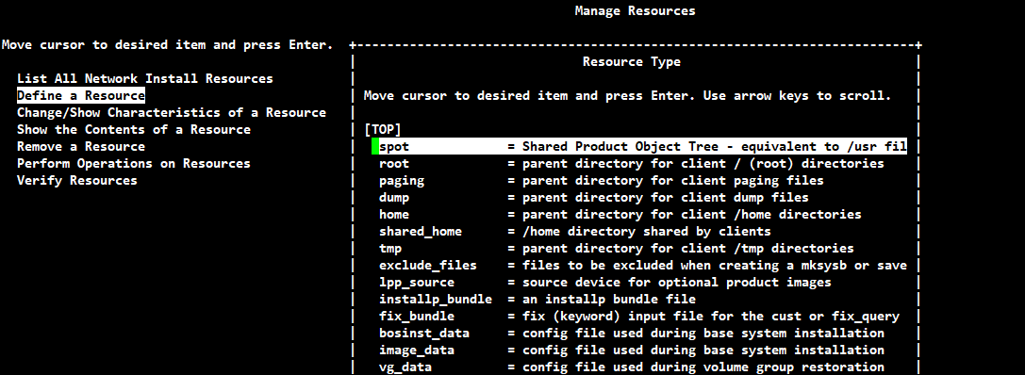
Select “spot = Shared Product Object Tree - equivalent to /usr fil” and enter.
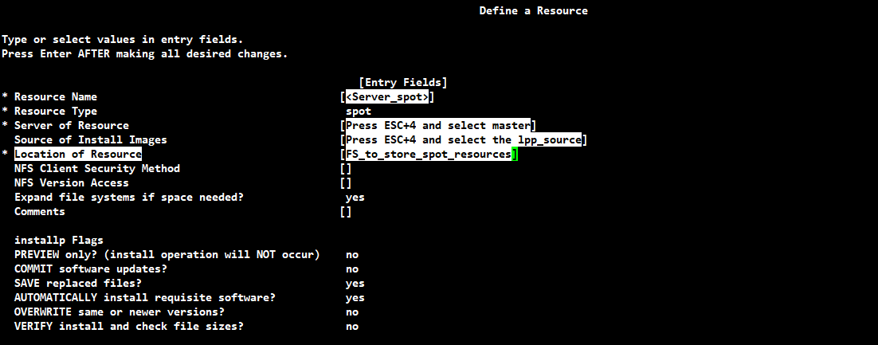
Fill the form with appropriate details and hit enter.
- Verify the created spot
  - lsnim -c resources
  - lsnim -l <created spot name>

Creating a mksysb resource in the client server:
- Add the client server as machines in NIM server:
# nim -o define -t standalone -a if1="<network name> <client name> 0" <client name>
Note: Verify the network settings should have proper network configuration
# lsnim -l <network name>
Network_name:
class = networks
type = ent
Nstate = ready for use
prev_state =
net_addr = <client subnet first IP>
snm = <client subnet mask>
routing1 = default <client gateway IP address>
- Create a mksysb of similar version of affected server:
  - For AIX server:
    - mksysb -i <backup dir/backup_file_name>
    - Copy it to the NIM server
  - For VIO server:
    - /usr/ios/cli/ioscli backupios -mksysb -file <mksysb_name> -nomedialib (Run as padmin)
    - backupios -mksysb -file <mksysb_file_name> -nomedialib (Run as root)
    - Copy it to the NIM server
- Create spot instance by using created mksysb.
# nim -o define -t spot -a source=<created_mksysb> -a server=master -a location=<location of spot files> <spot_name>
Select “Perform NIM Administration Tasks” and Enter
Select “Manage Resources” and Enter.
Select “Define a Resource” and Enter.
Select “spot = Shared Product Object Tree - equivalent to /usr fil” and enter.
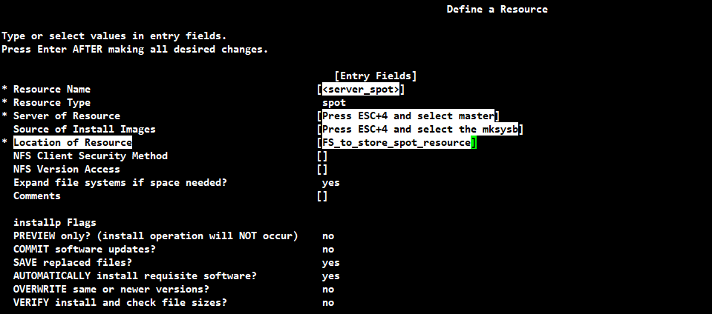
Fill the form with appropriate details and hit enter.
- Verify the created spot
  - lsnim -c resources
  - lsnim -l <created spot name>
Allocate the spot instance to the affected server in NIM master server:
- Allocate the created spot instance to affected server:
- Command: #nim -o maint_boot -a spot=<created spot name> <affected server name>
OR
Select “Perform NIM Administration tasks” and Enter.
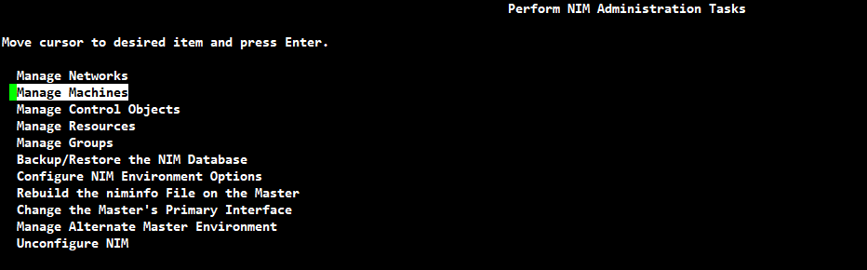
Select “Manage Machines” and Enter.
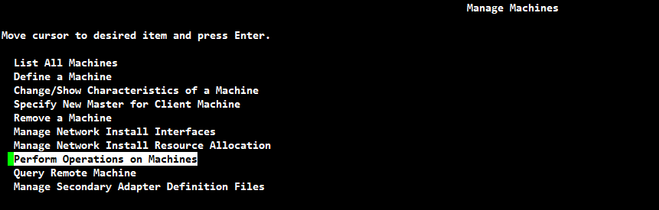
Select “Perform Operations on Machines” and Enter.
Select the affected server name and enter.
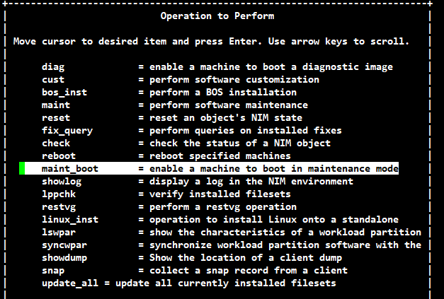
Select the “maint_boot = enable a machine to boot in maintenance mode” and enter.
Select the created spot resource and enter.
Reference Links:
Using NIM to boot into Maintenance Mode
Booting AIX into Maintenance Mode Using the HMC
NIM error warning messages
Requisites:
- A non-autoinstall mksysb taken from the same system or another system running the same level of AIX, either on tape or CD/DVD media.
- AIX bootable installation media (CD or DVD).
- A NIM server with a SPOT configured, and set up to boot this machine for maintenance work. This is the method we used for Last vios server recovery
Procedures:
- Log on to the HMC GUI (through browser) and CLI console(through putty) as a user (hscroot)
NOTE: Both consoles need to be opened before starting with below procedures
- Go to Systems Management Servers choose the server containing the LPAR you wish to boot
- Go to VIOS actions operations select the “shutdown” to power off the system
- Then select the “Activate” and select the Boot Mode to “SMS or System Management Services”
- Click finish.
- After the firmware is started, the console window should show the power up screen and then stop at the SMS menu (no need to press any key to get it to stop):
IBM IBM IBM IBM IBM IBM IBM IBM IBM IBM IBM IBM IBM IBM IBM IBM
IBM IBM IBM IBM IBM IBM IBM IBM IBM IBM IBM IBM IBM IBM IBM IBM
IBM IBM IBM IBM IBM IBM IBM IBM IBM IBM IBM IBM IBM IBM IBM IBM
IBM IBM IBM IBM IBM IBM IBM IBM IBM IBM IBM IBM IBM IBM IBM IBM
IBM IBM IBM IBM IBM IBM IBM IBM IBM IBM IBM IBM IBM IBM IBM IBM
1 = SMS Menu 5 = Default Boot List
8 = Open Firmware Prompt 6 = Stored Boot List
PowerPC Firmware
Version AM780_075
SMS 1.7 (c) Copyright IBM Corp. 2000,2008 All rights reserved.
-------------------------------------------------------------------------------
Main Menu
1. Select Language
2. Setup Remote IPL (Initial Program Load)
3. Change SCSI Settings
4. Select Console
5. Select Boot Options
-------------------------------------------------------------------------------

Navigation Keys: X = eXit System Management Services
-------------------------------------------------------------------------------
Type menu item number and press Enter or select Navigation key:5

PowerPC Firmware
Version AM780_075
SMS 1.7 (c) Copyright IBM Corp. 2000,2008 All rights reserved.
-------------------------------------------------------------------------------
Multiboot
1. Select Install/Boot Device
2. Configure Boot Device Order
3. Multiboot Startup <OFF>
4. SAN Zoning Support
-------------------------------------------------------------------------------
Navigation keys:
M = return to Main Menu
ESC key = return to previous screen X = eXit System Management Services
-------------------------------------------------------------------------------
Type menu item number and press Enter or select Navigation key:1
.------------------.
| PLEASE WAIT.... |
`------------------'
PowerPC Firmware
Version AM780_075
SMS 1.7 (c) Copyright IBM Corp. 2000,2008 All rights reserved.
-------------------------------------------------------------------------------
Select Device Type
1. Diskette
2. Tape
3. CD/DVD
4. IDE
5. Hard Drive
6. Network
7. List all Devices

-------------------------------------------------------------------------------
Navigation keys:
M = return to Main Menu
ESC key = return to previous screen X = eXit System Management Services
-------------------------------------------------------------------------------
Type menu item number and press Enter or select Navigation key:6

PowerPC Firmware
Version AM780_075
SMS 1.7 (c) Copyright IBM Corp. 2000,2008 All rights reserved.
-------------------------------------------------------------------------------
Select Network Service.
1. BOOTP
2. ISCSI
--------------------------------------------------------------------------------
Navigation keys:
M = return to Main Menu
ESC key = return to previous screen X = eXit System Management Services
-------------------------------------------------------------------------------
Type menu item number and press Enter or select Navigation key:1
PowerPC Firmware
Version AM780_075
SMS 1.7 (c) Copyright IBM Corp. 2000,2008 All rights reserved.
-------------------------------------------------------------------------------

Select Device
Device Current Device
Number Position Name
1. - Interpartition Logical LAN
( loc=U9117.MMD.107A627-V1-C10-T1 )
2. - Interpartition Logical LAN
( loc=U9117.MMD.107A627-V1-C11-T1 )
3. - Interpartition Logical LAN
( loc=U9117.MMD.107A627-V1-C12-T1 )
4. - Interpartition Logical LAN
( loc=U9117.MMD.107A627-V1-C13-T1 )
5. - Interpartition Logical LAN
( loc=U9117.MMD.107A627-V1-C14-T1 )
6. - Port 1 - IBM 10G Ethernet PCI-E Adapter
( loc=U2C4E.001.DBJN576-P2-C4-T1 )
-------------------------------------------------------------------------------
Navigation keys:
M = return to Main Menu N = Next page of list
ESC key = return to previous screen X = eXit System Management Services
-------------------------------------------------------------------------------
Type menu item number and press Enter or select Navigation key:16
PowerPC Firmware
Version AM780_075
SMS 1.7 (c) Copyright IBM Corp. 2000,2008 All rights reserved.
-------------------------------------------------------------------------------

Select Task
Int Multifunction Card w/ Base-TX 10/100/1000 1GbE
( loc=U2C4E.001.DBJN576-P2-C8-T3 )
1. Information
2. Normal Mode Boot
3. Service Mode Boot
-------------------------------------------------------------------------------
Navigation keys:
M = return to Main Menu
ESC key = return to previous screen X = eXit System Management Services
-------------------------------------------------------------------------------
Type menu item number and press Enter or select Navigation key:2
PowerPC Firmware
Version AM780_075
SMS 1.7 (c) Copyright IBM Corp. 2000,2008 All rights reserved.
-------------------------------------------------------------------------------
Are you sure you want to exit System Management Services?
1. Yes
2. No
-------------------------------------------------------------------------------
Navigation Keys:
X = eXit System Management Services
-------------------------------------------------------------------------------
Type menu item number and press Enter or select Navigation key:1

IBM IBM IBM IBM IBM IBM IBM IBM IBM IBM IBM IBM IBM IBM IBM IBM IBM IBM IBM IBM IBM IBM IBM IBM IBM IBM IBM IBM IBM IBM IBM IBM IBM IBM IBM IBM IBM IBM IBM IBM IBM IBM IBM IBM IBM IBM IBM IBM IBM IBM IBM IBM IBM IBM IBM IBM IBM IBM IBM IBM IBM IBM IBM IBM IBM IBM IBM IBM IBM IBM IBM IBM IBM IBM IBM IBM IBM IBM IBM IBM IBM IBM IBM IBM IBM STARTING SOFTWARE IBM IBM IBM IBM IBM IBM IBM IBM IBM IBM PLEASE WAIT... IBM IBM IBM IBM IBM IBM IBM IBM IBM IBM IBM IBM IBM IBM IBM IBM IBM IBM IBM IBM IBM IBM IBM IBM IBM IBM IBM IBM IBM IBM IBM IBM IBM IBM IBM IBM IBM IBM IBM IBM IBM IBM IBM IBM IBM IBM IBM IBM IBM IBM IBM IBM IBM IBM IBM IBM IBM IBM IBM IBM IBM IBM IBM IBM IBM IBM IBM IBM IBM
TFTP BOOT ---------------------------------------------------
Server IP.....................172.26.101.102
Client IP.....................172.25.10.17
Gateway IP....................172.25.10.1
Subnet Mask...................255.255.255.0
( 1 ) Filename................./tftpboot/li-prd-vio1.corp.follett.com
TFTP Retries..................5
Block Size....................512
PACKET COUNT = 100
PACKET COUNT = 200
PACKET COUNT = 300.
.
.
PACKET COUNT = 38800
PACKET COUNT = 38900
PACKET COUNT = 38900
FINAL PACKET COUNT = 38913
FINAL FILE SIZE = 19922944 BYTES
Elapsed time since release of system processors: 1843968 mins 2 secs

-------------------------------------------------------------------------------
Welcome to AIX.
boot image timestamp: 09:55:52 12/21/2024
The current time and date: 10:46:13 12/21/2024
processor count: 2; memory size: 10240MB; kernel size: 29311443
boot device: /pci@80000002000020b/ethernet@0,4:speed=auto,duplex=auto,172.26.101.102,,172.25.10.17,172.25.10.1,5,5,255.255.255.0,512
-------------------------------------------------------------------------------
******* Please define the System Console. *******
Type a 2 and press Enter to use this terminal as the system console.
Select 2 and Hit enter
************** Here it takes 5 – 10 minutes time to load *****************
>>> 1 Type 1 and press Enter to have English during maintenance.
>>> Choice [1]: 1
Maintenance
Type the number of your choice and press Enter.
>>> 1 Access a Root Volume Group
2 Copy a System Dump to Removable Media
3 Access Advanced Maintenance Functions
4 Erase Disks
5 Configure Network Disks (iSCSI)
6 Select Storage Adapters
88 Help ?
99 Previous Menu

>>> Choice [1]: 1

Warning:
If you choose to access a root volume group, you will NOT be able to return
to the Base Operating System Installation menus without rebooting.
Type the number of your choice and press Enter.

0 Continue
88 Help ?
>>> 99 Previous Menu
>>> Choice [99]: 0

Access a Root Volume Group

Type the number for a volume group to display the logical volume information
and press Enter.

1) Volume Group 00c7a61700004c0000000153d379089a contains these disks:
hdisk36 61440 03-03-01 500507680140f34d//003d000000000000 001a7a00
hdisk25 153600 03-03-01 500507680140f34d//002c000000000000 001a7a00
2) Volume Group 00c7a62700004c0000000143fdfe18a5 contains these disks:
hdisk51 140013 06-00-00
hdisk40 153600 03-03-01 500507680140f34d//0044000000000000 001a7a00
3) Volume Group 00c7a62700004c00000001440cd9e0e1 contains these disks:
hdisk55 140013 0E-00-00 hdisk52 140013 06-00-00
hdisk50 140013 06-00-00
4) Volume Group 00c7a61700004c00000001440991cd1d contains these disks:
hdisk4 71680 03-03-01 500507680140f34d//000e000000000000 001a7a00
5) Volume Group 00c7a61700004c00000001444751ff1b contains these disks:
hdisk5 212992 03-03-01 500507680140f34d//0013000000000000 001a7a00
6) Volume Group 00c7a62700004c00000001440d715aa3 contains these disks:
hdisk6 71680 03-03-01 500507680140f34d//0017000000000000 001a7a00
7) next page --->
Choice: 2
Volume Group Information
------------------------------------------------------------------------------
Volume Group ID 00c7a62700004c0000000143fdfe18a5 includes the following logical volumes:
hd5 hd6 paging00 hd8 hd4 hd2
hd9var hd3 hd1 hd10opt hd11admin livedump
lg_dumplv lg_dump2lv storixlv
------------------------------------------------------------------------------
Type the number of your choice and press Enter.

1) Access this Volume Group and start a shell
2) Access this Volume Group and start a shell before mounting filesystems

99) Previous Menu
Choice [99]: 1
Importing Volume Group...
rootvg
Checking the / filesystem.
The current volume is: /dev/hd4
Primary superblock is valid.
Checking the /usr filesystem.
The current volume is: /dev/hd2
Primary superblock is valid.
Saving special files and device configuration information.
Unable to stat /dev directory on disk
Recreating /dev directory on disk
Changed: audit
Changed: console
Changed: error
Changed: storixlv
.
.
Changed: ipl_blv
Changed: ipldevice
mergedev replaced 236 files in the hardfile /dev directory
Checking and mounting the /tmp filesystem.
The current volume is: /dev/hd3
Primary superblock is valid.
Checking and mounting the /var filesystem.
The current volume is: /dev/hd9var
Primary superblock is valid.
Checking and mounting the /opt filesystem.
The current volume is: /dev/hd10opt
Primary superblock is valid.
Filesystems mounted for maintenance work.
# df
Filesystem 512-blocks Free %Used Iused %Iused Mounted on
/dev/ram0 524288 178560 66% 6900 25% /
li-nim.net.follett.com:/export/spot/li-qa-vio2_spot/usr - - - - - /SPOT/usr
/proc 524288 178560 66% 6900 25% /proc
/dev/hd4 524288 178560 66% 6900 25% /
/dev/hd2 12058624 5254224 57% 73143 11% /usr
/dev/hd3 51904512 51217792 2% 1417 1% /tmp
/dev/hd9var 2097152 838632 61% 10925 10% /var
/dev/hd10opt 4194304 1913264 55% 13816 6% /opt
# passwd
Changing password for "root"
root's New password:
Re-enter root's new password:
*************commenting affecting NFS filesystem*****************
# sed -e "s/^\\/backupmksys_tsm/*&/" /etc/filesystems > /tmp/filesystem_bkp
# cat /tmp/filesystem_bkp
# cp /etc/filesystems /etc/filesystems_bkp_21122024
# cp /tmp/filesystem_bkp /etc/filesystems
# cat /etc/filesystems
# sync; sync; sync
# sync; sync; sync; reboot
Rebooting . . .
************It reboot and loads with base image of the actual server**********

